SIMATS ENGINEERING
Department of Computer Science & Engineering
ASSESSMENT TOOL 1-CONSTRAINT-BASED PROBLEM SOLVING
Course Code: | CSA12 | Course Title: | Computer Architecture for Multicore Systems
CO Assessed: | CO5 | Assessment: | ASSESSMENT TOOL1-  Constraint-Based Problem  Solving
Weightage: | 40% | Total Marks: | 25
CO5 Statement: | Construct I/O communication mechanisms by comparing memory-mapped and I/O-mapped techniques, interrupt handling (vectored, hardware, software), DMA controllers, and advanced bus interfaces including PCIe, USB, NVMe, and Thunderbolt.
Student Name: | Nishevitha Sri.S | Reg.No.: | 192511424
Department: | CSE | Date:

ANNEXURE A

Constraint-Based Problem Solving 1.Construct an I/O communication mechanism for a real-time embedded system with the following constraints:
- CPU utilization must be below 15%
- Multiple sensors generate interrupts every 1 ms
- Use vectored interrupt handling
- Select between memory-mapped and I/O-mapped I/O for optimal latency
2.Design an I/O subsystem under these constraints:
- High-speed storage requires throughput > 3 GB/s
- Must use NVMe over PCIe
- CPU should not handle bulk data transfer
- Integrate DMA controller with interrupt notification
3.Construct a multi-device communication architecture with constraints:
- 6 peripherals using USB, 2 high-speed devices using Thunderbolt
- Avoid interrupt starvation
- Use hardware and software interrupts
- Ensure fair bus arbitration
4.Design a data acquisition system with constraints:
- Continuous data stream at 500 MB/s ● Minimal CPU intervention required
- Must compare DMA transfer vs interrupt-driven I/O
- Use memory-mapped I/O for device registers
5.Construct an interrupt handling mechanism with constraints:
- Support nested interrupts
- Maximum interrupt latency < 10 µs
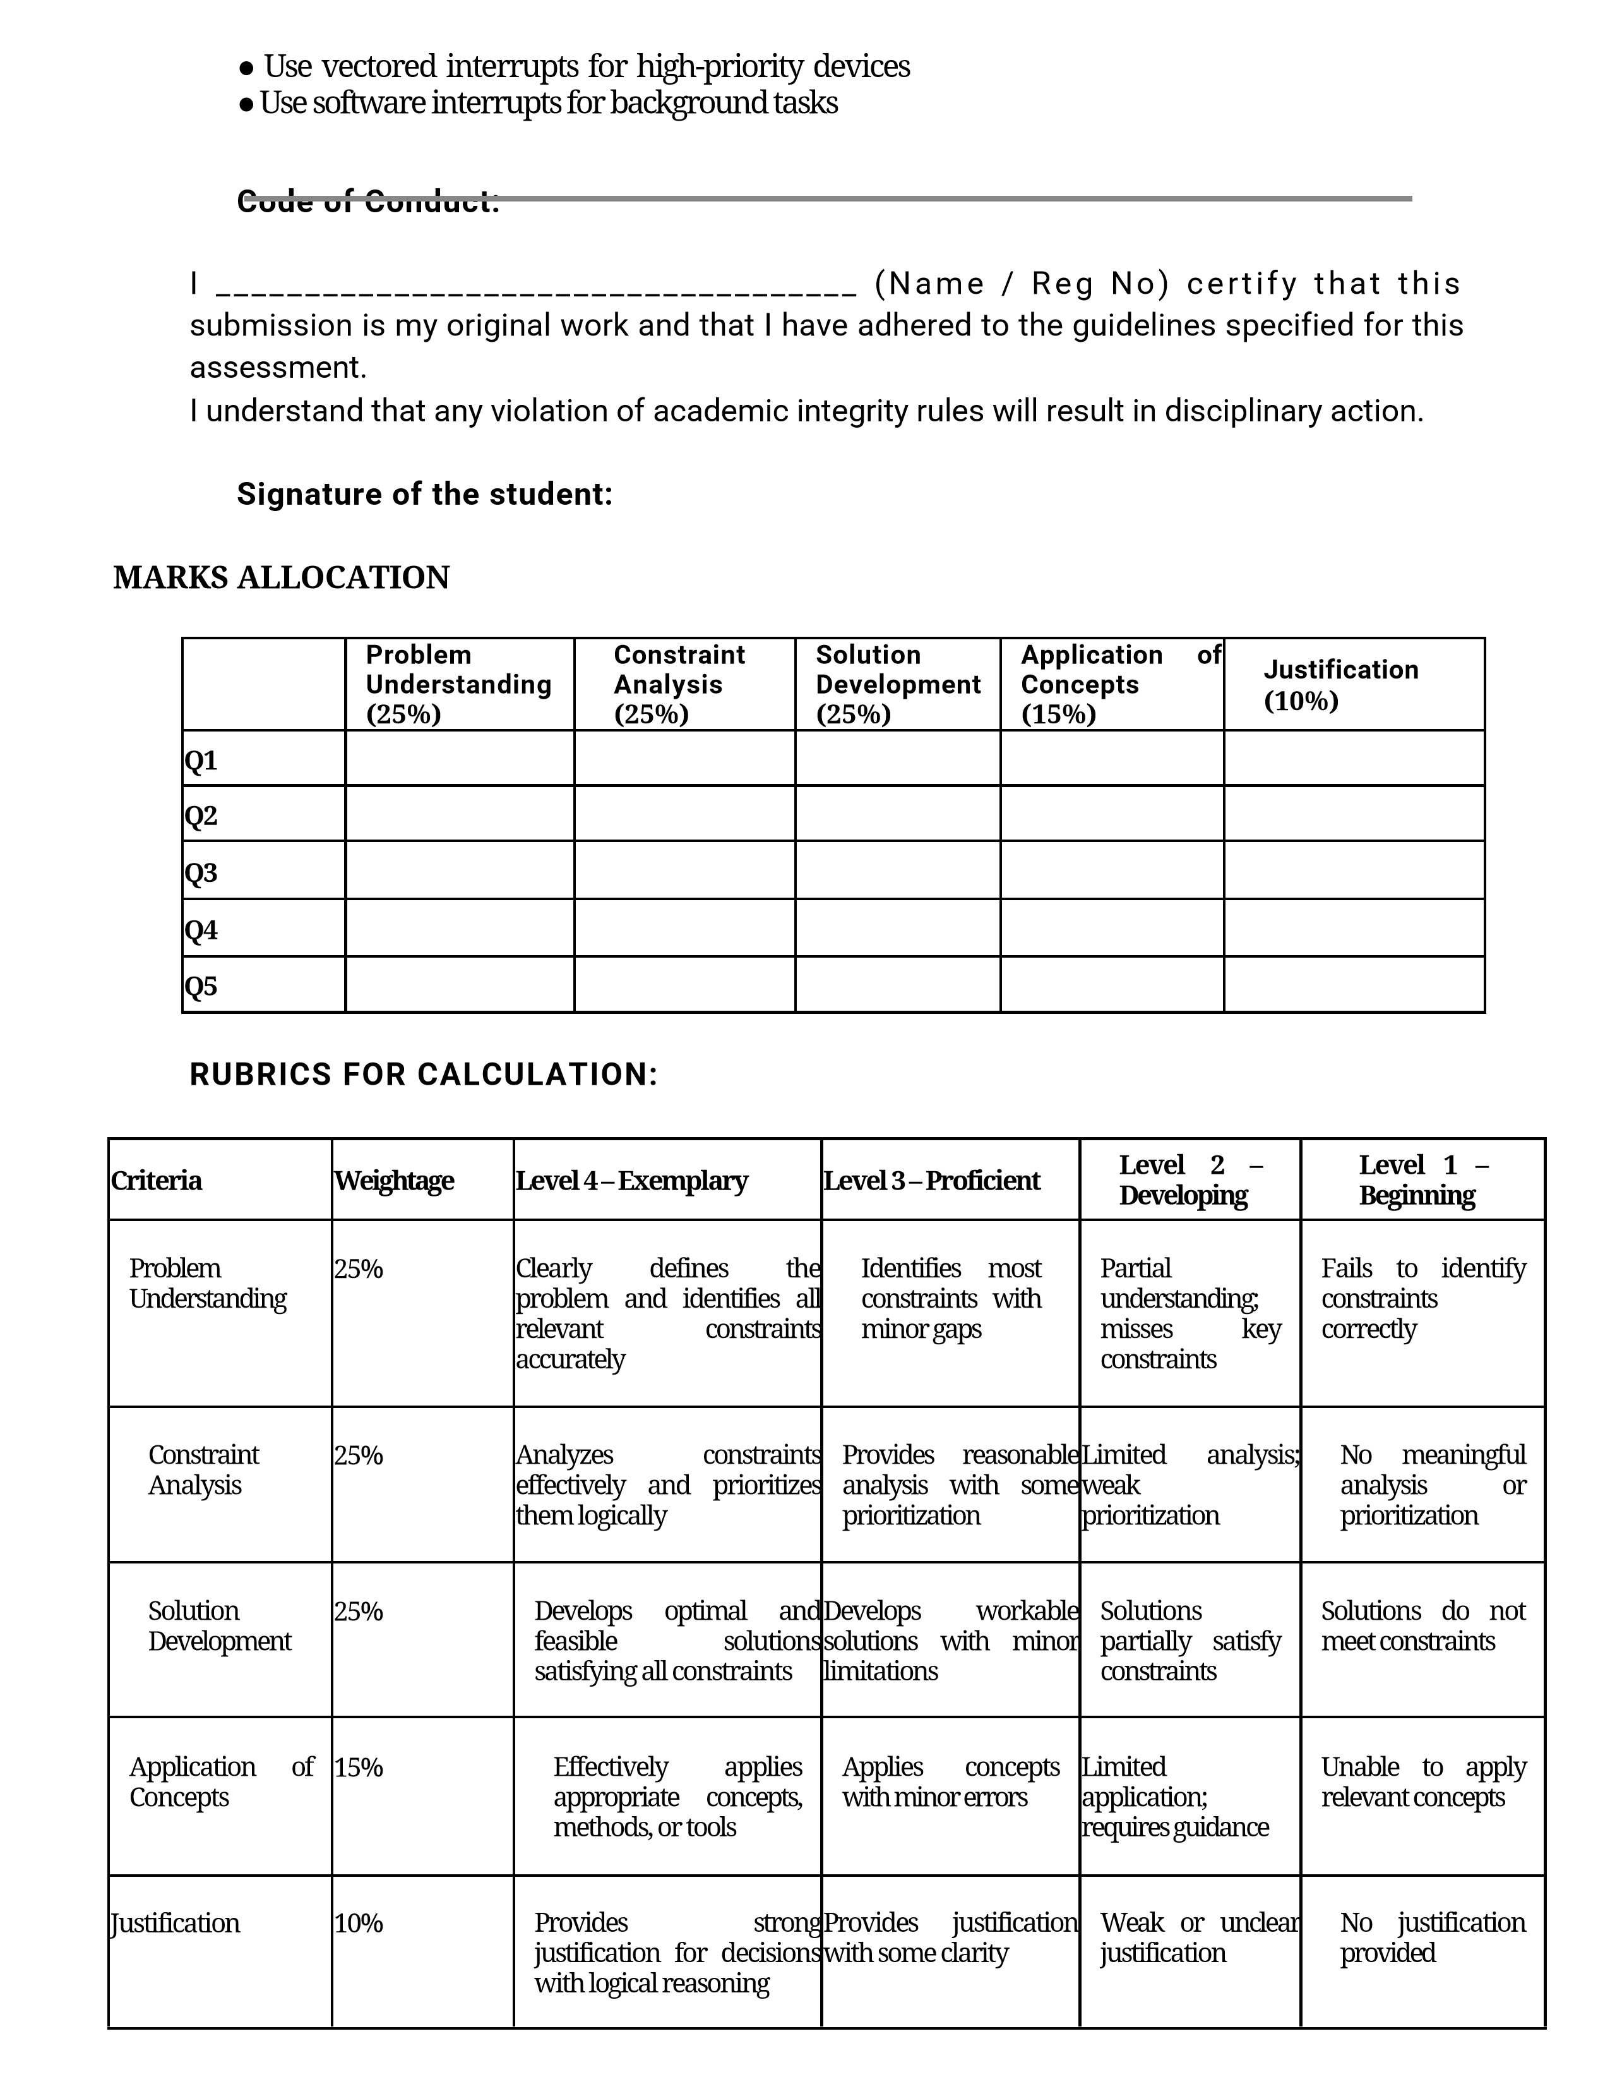

ANNEXURE A
Below are exam-ready answers for all 5 questions. I’ve written them in a clear constraint → design → working → justification format.
ANNEXURE A – Constraint-Based Problem Solving
1. I/O Communication Mechanism for a Real-Time Embedded System

Constraints
- CPU utilization must be below 15%.
- Multiple sensors generate interrupts every 1 ms.
- Use vectored interrupt handling.
- Select between memory-mapped I/O and I/O-mapped I/O for optimal latency.

Solution
A vectored interrupt-based memory-mapped I/O mechanism is suitable for the real-time embedded system. Each sensor is connected to an interrupt controller, and every sensor is assigned a unique interrupt vector.

Architecture
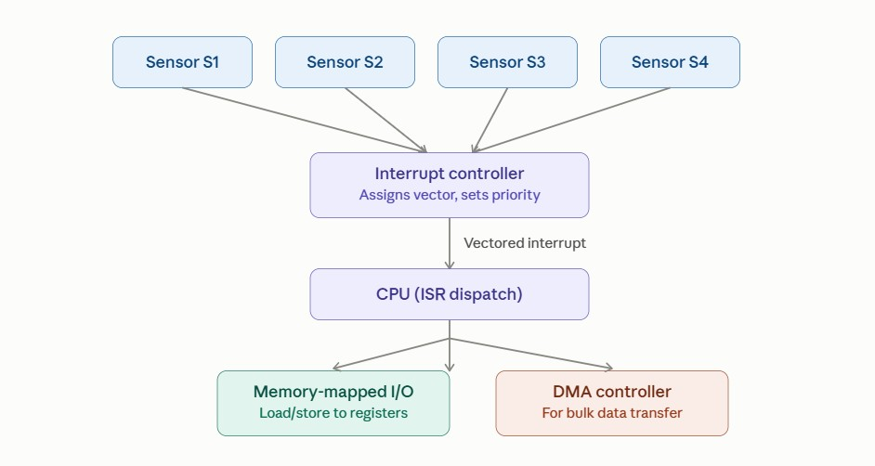

Working
- Sensors continuously monitor physical parameters.
- When a sensor requires CPU attention, it generates an interrupt.
- The interrupt controller identifies the source.
- The corresponding interrupt vector directly points to the appropriate ISR.
- The CPU executes the ISR and reads the sensor register.
- After servicing, the CPU returns to the previous task.
- DMA can be used for larger sensor data transfers to further reduce CPU utilization. Memory-Mapped vs I/O-Mapped I/O
I/OMemory-Mapped
Feature Mapped

I/O
I/O
Address Shared with Separate I/O space memory address space
Normal memory Special I/O
Instructions
instructions instructions
Programming Easier More specialized
Low, but
Latency Low architecture-
dependent
Suitable here Yes Less preferred

Justification
Memory-mapped I/O is selected because it provides simple and fast access to sensor registers and integrates well with the processor's normal load/store operations. Vectored interrupts reduce interruptidentification overhead. DMA can be added for bulk data transfer.

Conclusion
The proposed system achieves low interrupt latency and keeps CPU utilization below 15% by combining memory-mapped I/O, vectored interrupts, interrupt prioritization, and DMA.

2. I/O Subsystem for High-Speed NVMe Storage

Constraints
- Throughput must be greater than 3 GB/s.
- Must use NVMe over PCIe.
- CPU should not handle bulk data transfer.
- DMA controller must be integrated with interrupt notification.

Solution
Use an NVMe SSD connected through PCIe, with DMA-based data transfer between the SSD and main memory.
Architecture

Working
- CPU sends an NVMe command through the NVMe driver.
- The NVMe controller processes the command.
- Data is transferred directly between the NVMe device and RAM using DMA.
- CPU does not copy the bulk data.
- After completing the transfer, the NVMe controller generates an interrupt.
- The CPU handles the completion notification.
- NVMe queues allow multiple commands to be processed efficiently.
Why DMA?
Without DMA:
NVMe → CPU → Memory
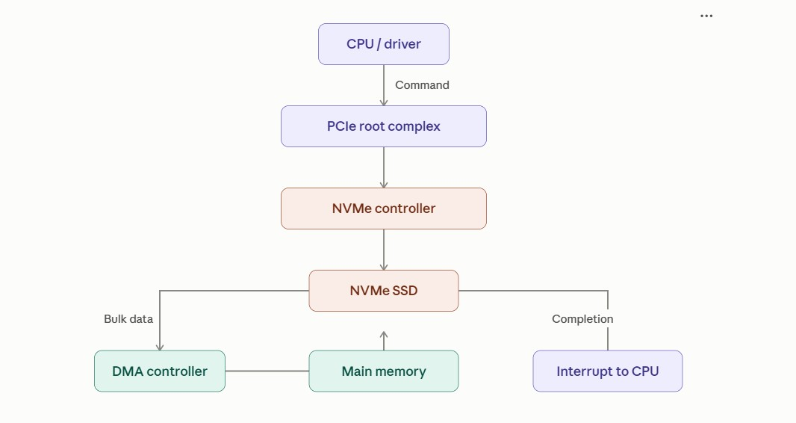
The CPU would spend significant time moving data.
With DMA:
NVMe → DMA → Memory
The CPU only manages commands and completion notifications.

Throughput
PCIe provides high-bandwidth communication, while NVMe is designed for high-speed storage and parallel queues. The design should use an appropriate PCIe generation/lane configuration capable of sustaining >3 GB/s in practice.

Conclusion
The optimal subsystem is NVMe + PCIe + DMA + interrupt notification. This achieves high throughput while keeping CPU involvement low.

3. Multi-Device Communication Architecture

Constraints
- 6 USB peripherals.
- 2 high-speed Thunderbolt devices.
- Avoid interrupt starvation.
- Use hardware and software interrupts.
- Ensure fair bus arbitration.

Architecture
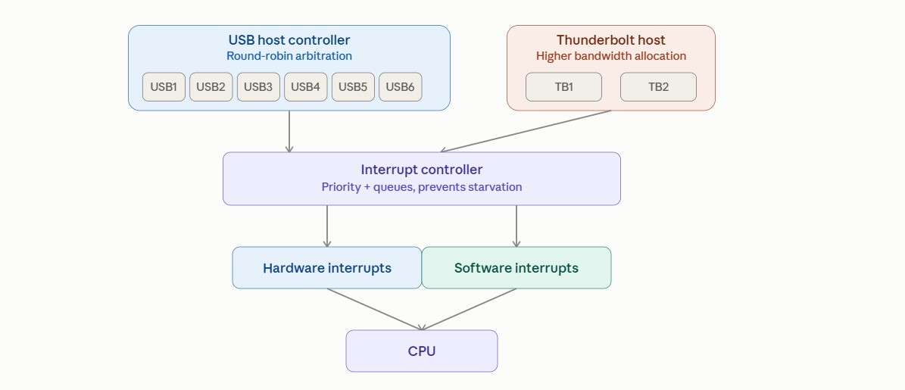

Working
- Six USB devices communicate through the USB host controller.
- Two high-speed devices communicate through Thunderbolt.
- Hardware interrupts are generated by devices requiring immediate attention.
- Software interrupts are used for OS services and deferred/background processing.
- An interrupt controller assigns priorities to interrupts.
- High-priority interrupts are serviced first.
- Lower-priority interrupts are placed in queues instead of being permanently blocked.
- Fair bus arbitration allocates communication opportunities among devices. Avoiding Interrupt Starvation Use:
- Priority-based interrupt handling.
- Round-robin service for devices of equal priority.
- Interrupt masking only for very short critical sections.
- Interrupt queues.
- Deferred interrupt processing for lengthy operations.

Fair Bus Arbitration
A round-robin arbitration mechanism can be used:
USB1 → USB2 → USB3 → USB4 → USB5 → USB6
↑ ↓
+------------- Repeat ----------------+
Thunderbolt devices can receive higher bandwidth allocations when required, while arbitration prevents any device from monopolizing the shared resources.

Conclusion
The architecture supports 6 USB + 2 Thunderbolt devices while preventing interrupt starvation through priorities, queues, round-robin arbitration, hardware interrupts, and software interrupts.

4. Data Acquisition System – 500 MB/s

Constraints
- Continuous data stream of 500 MB/s.
- Minimal CPU intervention.
- Compare DMA transfer vs interrupt-driven I/O.
- Use memory-mapped I/O for device registers.

Architecture
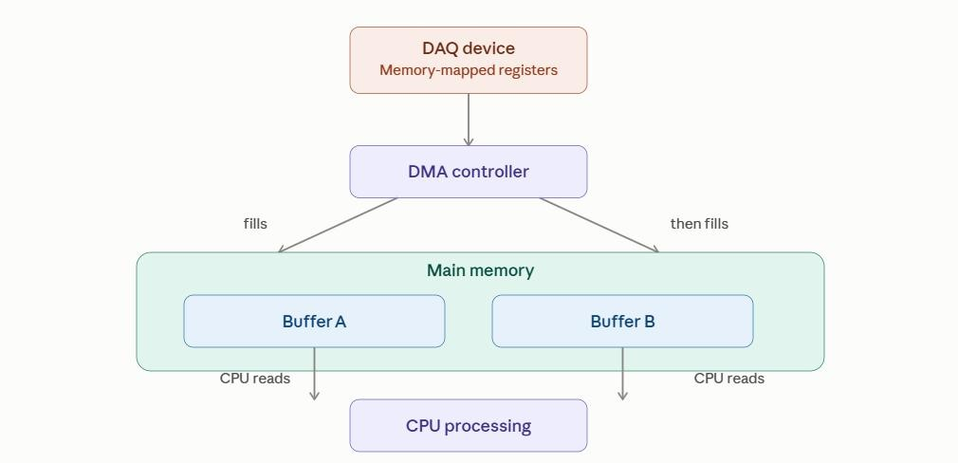

Working
- The data acquisition device continuously generates data.
- Its control/status registers are accessed using memory-mapped I/O.
- DMA is configured with:
o Source address o Destination address o Transfer size
- The device transfers data directly to memory.
- DMA generates an interrupt after a block transfer is completed.
- CPU processes the completed buffer while DMA fills another buffer.

Double Buffering
Device
| v
+---------+ +---------+
| Buffer A| | Buffer B|
+---------+ +---------+
↑ ↑
DMA CPU
While DMA fills Buffer A, the CPU processes Buffer B. Then they switch.
DMA vs Interrupt-Driven I/O

Parameter DMA Interrupt-Driven I/O
CPU involvement Very low High Suitable for 500 MB/s Yes No
Device ↔ CPU ↔
Data movement Direct device ↔ memory
memory
Potentially
Interrupt frequency Block-based
very high
CPU overhead Low High
Performance High Lower

Why DMA is Better
At 500 MB/s, interrupt-driven I/O would require frequent CPU intervention and could consume significant processing time. DMA transfers large blocks directly to memory and interrupts the CPU only when necessary.

Conclusion
The best solution is memory-mapped I/O + DMA + double buffering. It provides continuous 500 MB/s acquisition with minimal CPU intervention.

5. Interrupt Handling Mechanism

Constraints
- Support nested interrupts.
- Maximum interrupt latency < 10 µs.
- Use vectored interrupts for high-priority devices.
- Use software interrupts for background tasks.

Architecture
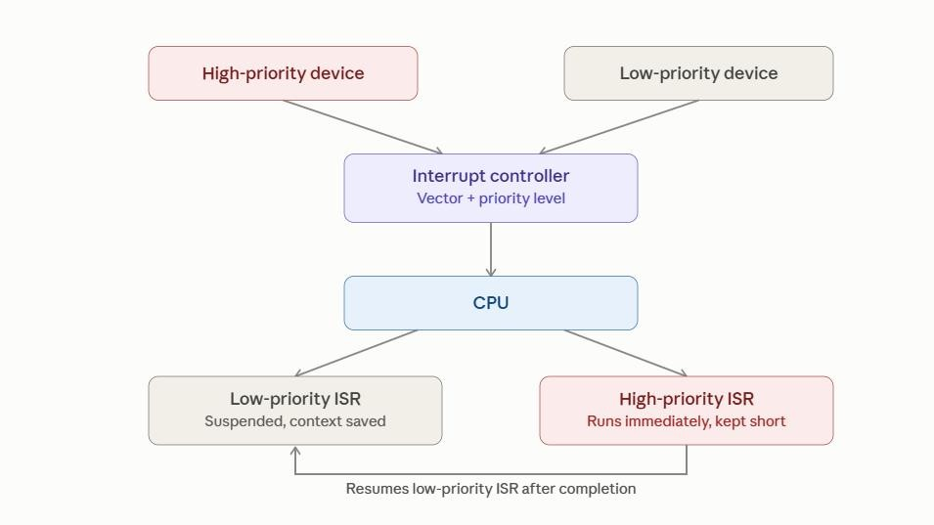

Working
- A device generates an interrupt.
- The interrupt controller determines its priority.
- A high-priority device receives a vectored interrupt.
- CPU immediately jumps to its corresponding ISR.
- If another higher-priority interrupt occurs during ISR execution, the current ISR can be temporarily suspended.
- CPU saves the current context and services the higher-priority interrupt.
- After completion, the previous ISR resumes.
- Software interrupts are used for deferred/background processing.

Nested Interrupt Example
Main Program
| v
Low Priority ISR
|
|---- High Priority Interrupt
| |
| v
| High Priority ISR
| |
| v
| Return to Low ISR
| v
Main Program

Meeting the <10 µs Requirement
To minimize interrupt latency:
- Use vectored interrupts.
- Keep ISRs short.
- Use a fast interrupt controller.
- Use priority levels.
- Avoid unnecessary interrupt masking.
- Move lengthy processing to deferred/software interrupt handlers.
- Use DMA for large data transfers.

Priority Structure
Priority 1 → Emergency / Real-Time Device
Priority 2 → High-Speed I/O
Priority 3 → Normal I/O
Priority 4 → Background Tasks

Conclusion
A priority-based nested interrupt system with vectored interrupts provides fast response for critical devices. Software interrupts handle non-critical background tasks, while short ISRs help maintain the required <10 µs maximum interrupt latency.

Quick Final Summary

Question Best Design
1 Memory-mapped I/O + vectored interrupts + DMA 2 NVMe + PCIe + DMA + completion interrupts
USB + Thunderbolt + priority interrupts + round-
3
robin arbitration
- Memory-mapped I/O + DMA + double buffering
Nested vectored interrupts + priority controller +
- software interrupts



